**Linux Documentation Project**

The Linux Documentation Project (LDP) is working on developing good, reliable documentation for the Linux operating system. The overall goal of the LDP is to collaborate in taking care of all of the issues of Linux documentation, ranging from online documentation (man pages, HTML, and so on) to printed manuals covering topics such as installing, using, and running Linux.



The LDP has a number of mirror sites worldwide where one may inspect and/or download LDP documents.

The main site is [**http://tldp.org**](http://tldp.org/). Go here to find the list of **[mirror sites](http://wiki.tldp.org/Mirrors)** and then use the nearest mirror site.

**The Man Pages**

The man (manual) pages are very structured documentation source, as you will see from the example below:

Type the command like this at the prompt, and press Enter:

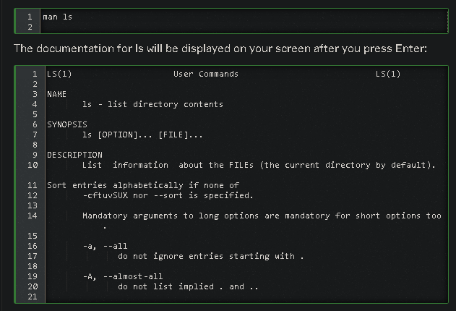

Browse to the next page using the space bar. You can go back to the previous page using the b-key. When you reach the end, man will usually quit and you get the prompt back. Type q if you want to leave the man page before reaching the end, or if the viewer does not quit automatically at the end of the page.

Each man page usually contains a couple of standard sections, as we can see from the man ls example:

* The first line contains the name of the command you are reading about and the id of the section in which this man page is located. The man pages are ordered in chapters.
* The name of the command and a short description are given, which is used for building an index of the man pages.
* The synopsis of the command provides a technical notation of all the options and/or arguments this command can take. You can think of an option as a way of executing the command. The argument is what you execute it on.
* A longer description of the command is given.
* Options with their descriptions are listed. Options can usually be combined.
* There might also be author and copyright information.
* A reference to other man pages is given in the “SEE ALSO” section.
* Usually, there is also information about known bugs (anomalies) and where to report new bugs you may find.

**The Info Pages**

You can also read the Info pages about a command in addition to the man pages, using the info command.

Start by typing info ls in a terminal window.

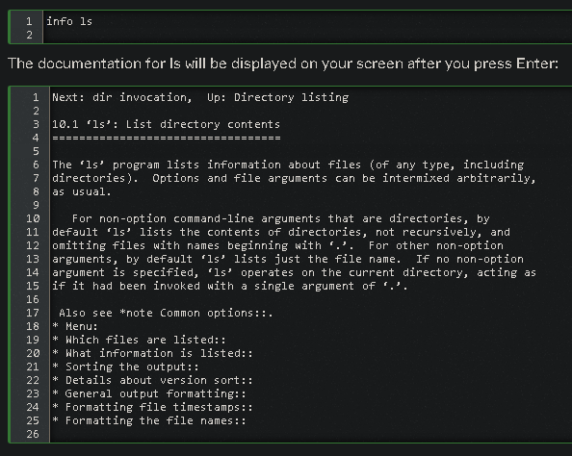

Use the arrow keys to browse through the text and move the cursor on a line starting with an asterisk, containing the keyword about which you want info, then hit Enter. Use the P and N keys to go to the previous or next subject. The space bar will move you one page further, no matter whether this starts a new subject or an Info page for another command. Use Q to quit.

**The whatis Command**

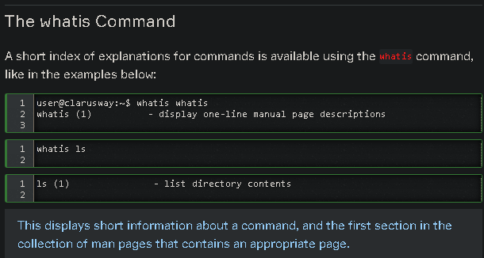Formun Üstü

Formun Altı

**The apropos Command**

If you don't know where to get started and which man page to read, apropos gives more information. apropos searches the manual pages for a keyword or regular expression.

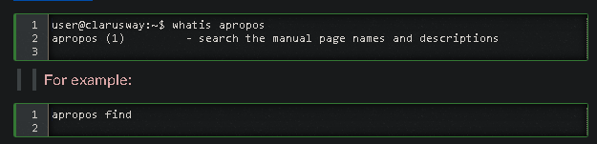

Display all manual entries with the word "find" in the page name or description. The output will resemble the following:

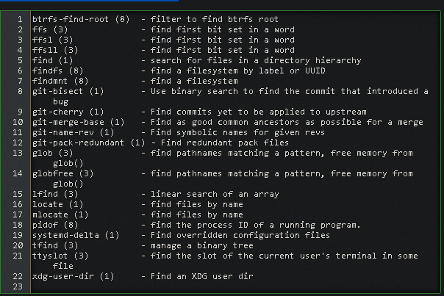

**The --help Option**

Most GNU commands support the --help, which gives a short explanation about how to use the command and a list of available options. Below is the output of this option with the ls command:

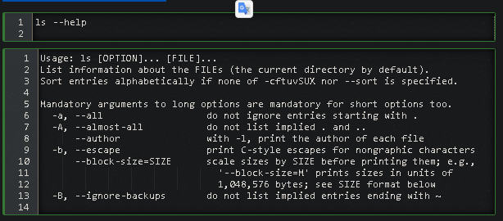

**Q:** You want to do something from Linux command line but you have some doubts. How can you search a command or take information about a command from linux **terminal**?  
**A:** There are many ways to searching information for commands. The **man** command gives you to very structured documentation for commands. You can also read the information about a command in addition to the man pages, using the **info** command. The shortest index of explanations for commands is available using the **whatis** command.  
The parameter of the **--help** gives a short explanation about how to use the command and a list of available options (parameters).  
If you don't know where to get started and **apropos** searches the manual pages for a keyword or regular expression.

 - Interview Q&A

Complementary Lesson about Linux Getting Help

<https://youtu.be/QSPPGmS-UPA>